**DAILY ONLINE ACTIVITIES SUMMARY**

|  |  |  |  |  |  |  |  |
| --- | --- | --- | --- | --- | --- | --- | --- |
| **Date:** | **19-06-2020** | | | | **Name:** | **B.A.SOHANKUMAR** | |
| **Sem & Sec** | **4TH SEM A** | | | | **USN:** | **4AL18CS013** | |
| **Online Test Summary** | | | | | | | |
| **Subject** | | **MICRO CONTROLLER AND EMBEDDED SYSTEMS** | | | | | |
| **Max. Marks** | | **20** | | **Score** | | **20** | |
| **Certification Course Summary** | | | | | | | |
| **Course** | **FRONT END DEVELOPMENT-HTML** | | | | | | |
| **Certificate Provider** | | | **GLA** | **Duration** | | | **3.5 HOURS** |
| **Coding Challenges** | | | | | | | |
| **Problem Statement: Write a c program to count total set bits in all numbers from 1 to n.** | | | | | | | |
| **Status:EXECUTED** | | | | | | | |
| **Uploaded the report in Github** | | | | **YES** | | | |
| **If yes Repository name** | | | | **LOCKDOWN CODING** | | | |
| **Uploaded the report in slack** | | | | **YES** | | | |

**ONLINE TEST DETAILS:**

Online test was on 4th module of MICROCONTROLLER AND EMBEDDED SYSTEMS .The duration of the test was 30 minutes from 03.00pm to 03.30pm.Questions were of multiple choice.Score I received is 20/20.

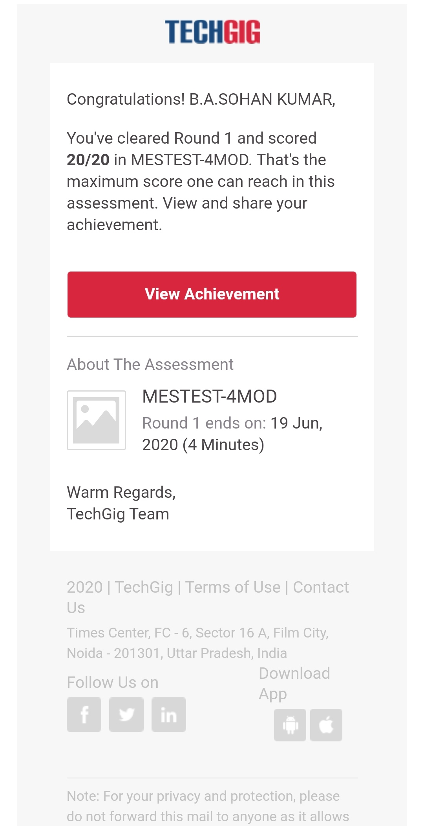

**CERTIFICATION COURSE DETAILS:**

Course:FRONT END DEVELOPMENT-HTML

Today I have opted this new course and the duration of this course is 3.5 hours.Completed topics today on this course are Introduction to Front-end,Creating an HTML File,HTML Structure,Paragraph Tags,More on HEAD Tags,Heading Tag,Hr and Br Tag,Anchor Tag,Absolute and Relative path,Link it online,Image Tag, Alt Attribute,Clickable Image,Unordered Lists,Ordered Lists, Tables 1,Tables 2,Introduction to Forms, Introduction to input elements.

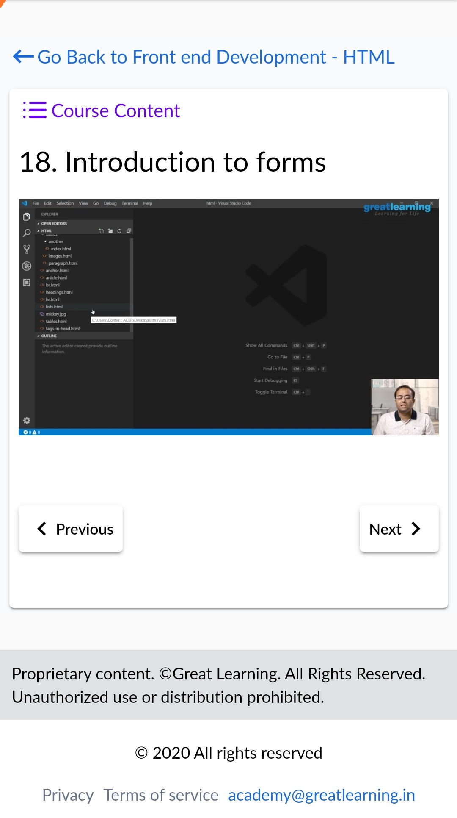 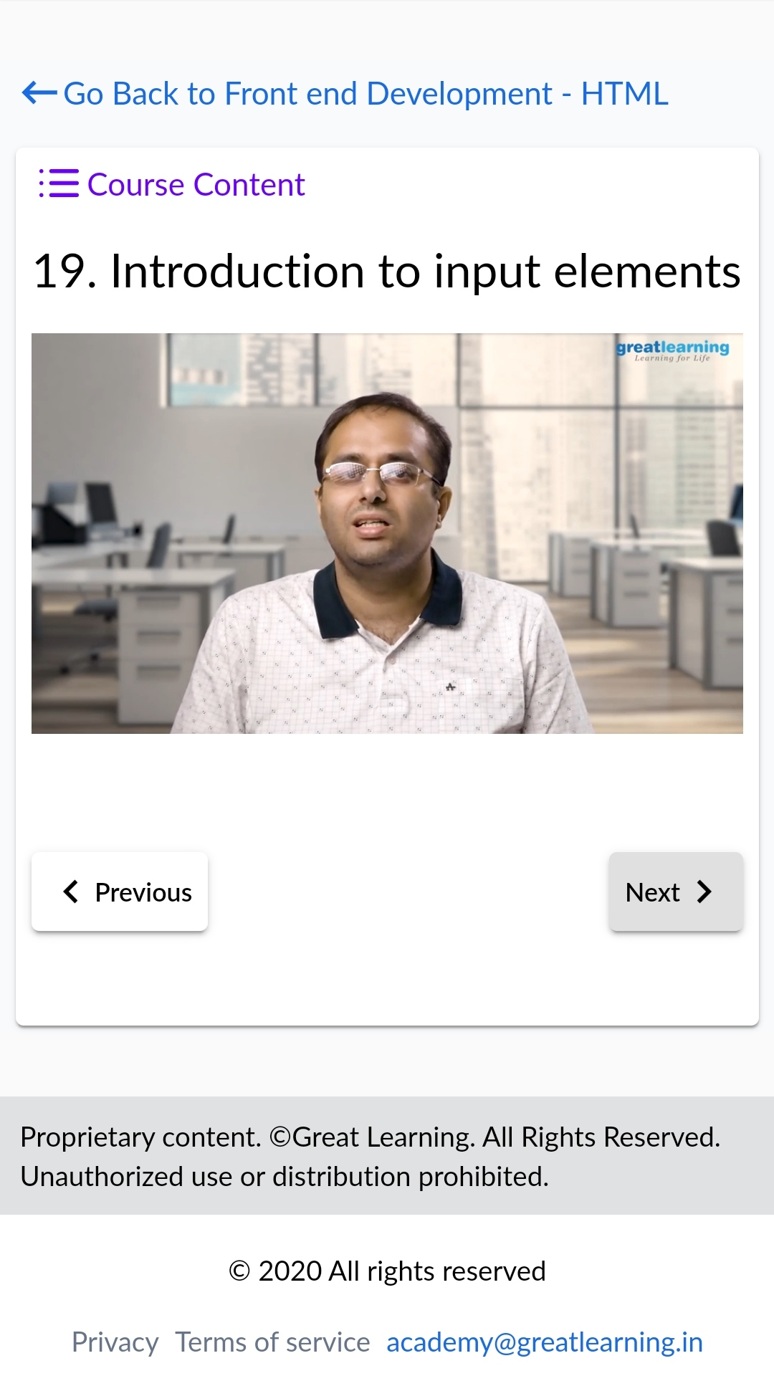

**CODING CHALLENGES DETAILS:**

1.Write a C Program to Count total set bits in all numbers from 1 to n.Given a positive integer n, count the total number of set bits in binary representation of all numbers from 1 to n.

Examples:

Input: n = 3

Output: 4

Input: n = 6

Output: 9

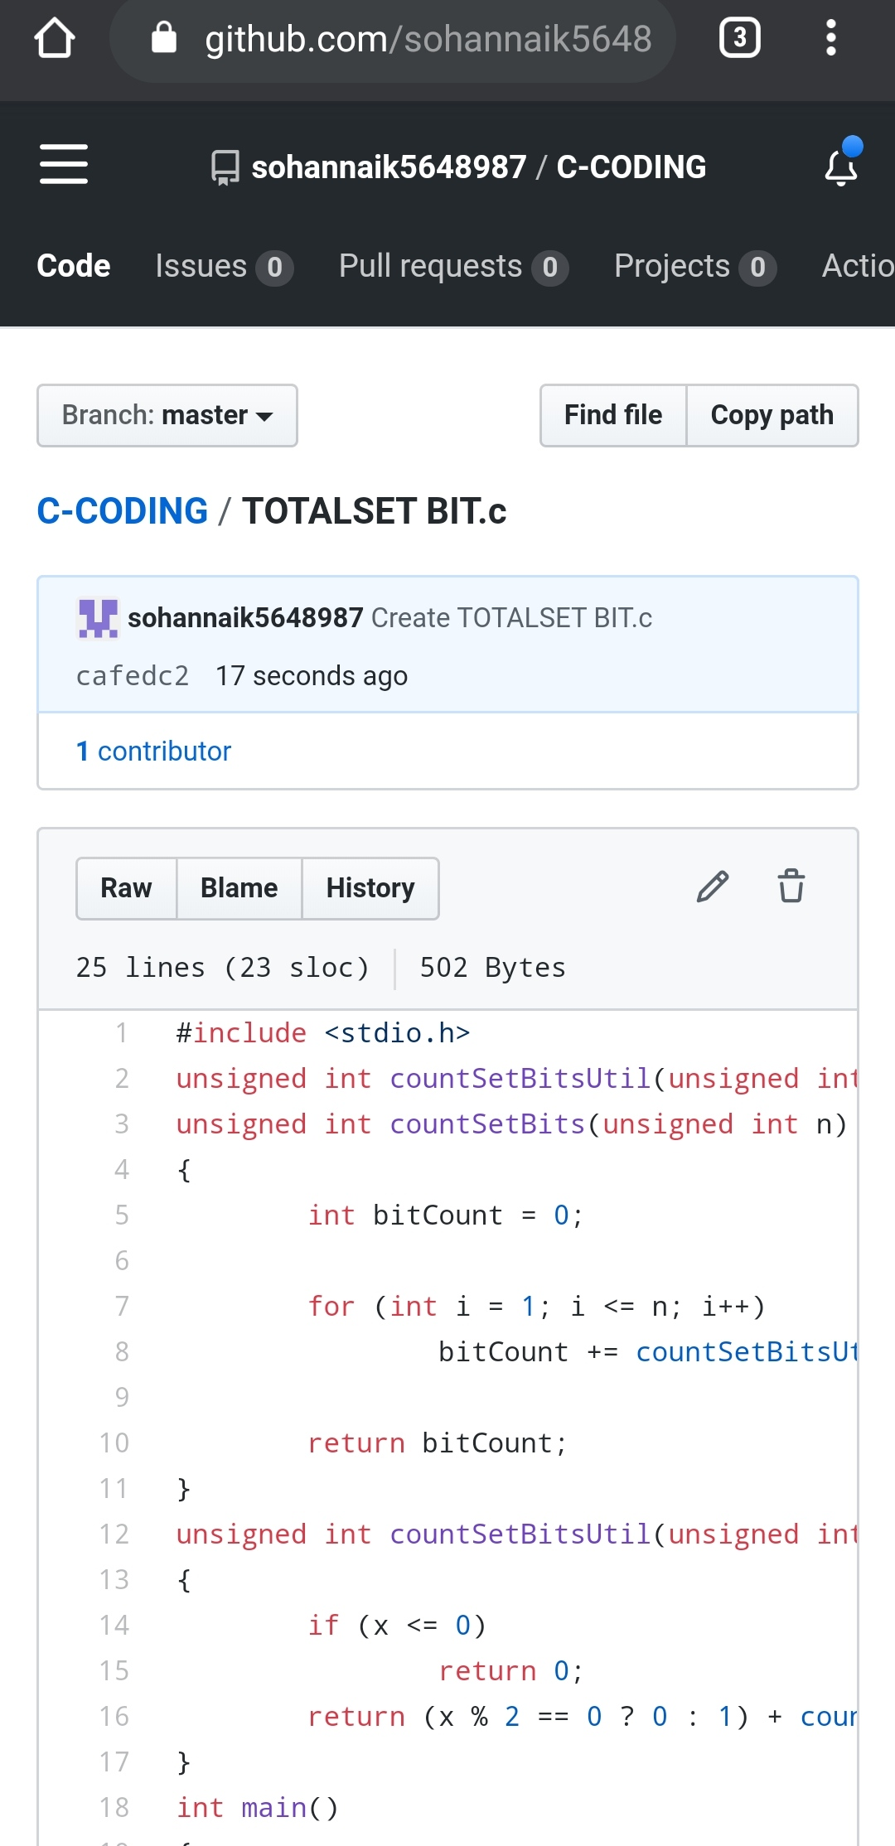

REPOSITORY LINK:https://github.com/sohannaik5648987/C-CODING